INDEX

|  |  |  |  |
| --- | --- | --- | --- |
| S.NO | NAME OF PRACTICAL | SUBMISSION  DATE | REMARK |
| 1. | Design a Professional Resume using Templates. | 22-09-2025 |  |
| 2. | Create a Career Oriented  Presentaon with 7 slides using Transions and Animaons. | 29-09-2025 |  |
| 3. | Create a social media poster for  “DIGITAL AWARENESS WEEK” using | 01-10-2025 |  |
| 4. | Canva.Compose & send a professional email with an aachment as “you are applying for an internship, send email to HR with your resume aached”. | 06-10-2025 |  |
| 5. | Design a complete Google Form survey and analyze responses.  a)Create a Google Form tled “Student Aendance Report”.  b)Include the following queson types:   1. 5 MCQs 2. 1 Rang scale (1–5) 3. 1 Short answer 4. 1 Checkbox queson   c)Customize the theme (header image + color).  d)Share the form link with 5 friends and collect responses. | 11-10-2025 |  |

|  |  |  |  |
| --- | --- | --- | --- |
|  | e)Generate charts from responses and take screenshots of the analysis page. |  |  |
| 6. | Demonstrate the creaon and management of your digital identy.  a)Create a social media profile (LinkedIn preferred).  b)Add a profile photo, short bio, skills, and educaon details.  c)Create a simple post about “My Learning Journey in Digital Literacy.”d)Change your privacy sengs to:   1. Who can see your posts. 2. Who can message you | 31-10-2025 |  |
| 7. | Using Google Drive or OneDrive:  a)Create a new folder named “Unit 3 Praccal Work”.  b)Upload 3 different files (PDF, image, document).  c)Organize them in subfolders: Notes, Images, Assignments.  d)Share the main folder with your teacher with View Only permission. | 13-11-2025 |  |
| 8. | Idenfy one real phishing email : A final-year student, Aman, receives a LinkedIn message saying:  “You are shortlisted for a Remote  Soware Developer role at Google.  Salary: ₹18 LPA.  Pay ₹2,499 as verificaon fee.  Limited seats. Pay now to confirm.” | 19-11-2025 |  |

|  |  |  |  |
| --- | --- | --- | --- |
|  | ANSWER THE QUESTIONS :-  a)What type of cybercrime is happening here?  b)List 3 red flags that show it is a scam?  c)What should he do to verify if a job offer is real? |  |  |
| 9. | Create a Google Form Quiz with the following requirements:  a)Convert the form into a Quiz mode with automac grading.  b)Add 5 MCQ quesons, each carrying 2 marks.  c)Add 1 short answer queson that requires manual evaluaon.   1. Turn ON the seng: 2. Limit to 1 response 3. Shuffle queson order 4. Release marks aer manual review   e)Add a mer add-on (like form presenter) and set up a 10-minute me limit.  f)Finally, send the quiz link and view the response summary. | 24-11-2025 |  |
| 10. | Ask ChatGPT OR Google Gemini to generate a 100–120 word paragraph on:  “Is online learning beer than offline learning for college students?”  a)Run the AI-generated text through Grammarly and any plagiarism- check tool. | 29-11-2025 |  |

|  |  |  |  |
| --- | --- | --- | --- |
|  | b)Now manually search online to check if similar sentences exist on blogs or arcles.  c)Idenfy 2–3 biased statements in the AI answer, such as:  i. Over-generalizaons ii. One-sided opinions iii. Unproven claims  d)Rewrite the enre paragraph in a neutral and balanced way, using AI only for grammar suggesons. e)Submit 3 screenshots:  i. Plagiarism check result ii. Grammarly suggeson page iii. Original AI paragraph vs your rewrien unbiased version |  |  |
| 11. | To compare AI-generated content with student-created content and understand limitaons of AI.  a)Write a 100–150 word paragraph on the topic:  “Will AI replace jobs or change them?”  (This must be wrien by the student.)  b)Ask any AI tool  (ChatGPT/Gemini/Copilot) to write the same topic.  c)In your praccal copy, create a Comparison Table with the headings:  i. Human-Generated Content ii. AI-Generated Content | 03-12-2025 |  |
| 12. | Create a new NotebookLM project tled: “My Chapter Revision Notes.” | 10-12-2025 |  |

|  |  |  |  |
| --- | --- | --- | --- |
|  | a)Upload mulple sources (any 2) such as:  i. PDF notes ii. Web arcles  iii. Text copied into NotebookLM b)Ask NotebookLM to:   1. Create a combined study guide using all sources. 2. Generate flashcards for quick   revision. iii. Create a concept map or explanaon of the topic. c)Manually check for:  i. Any incorrect facts ii. Repeated informaon iii. Missing important points d)Aach 3 screenshots from NotebookLM:  i. Combined study guide ii. Flashcards iii. Concept map / explanaon |  |  |
| 13. | Create a complete Student Result Management workbook.  a)Create a new workbook with 3 sheets renamed as:   1. Student_Data 2. Marks_Analysis 3. Charts   b)In Student_Data, enter a list of 15 students with:  Name, Roll No, Class, City, Subject1, Subject2, Subject3.  c)Use Flash Fill to split “Full Name” into “First Name” and “Last Name”.  d)Use Find & Replace to replace city name “Delhii” with correct “Delhi”. | 19-12-2025 |  |

|  |  |  |  |
| --- | --- | --- | --- |
|  | e)Use IF funcon to calculate Pass/Fail (Pass = total ≥120).  f)Use COUNTIF to find how many students belong to “Delhi”.  g)Use AVERAGE, MAX, MIN to analyze marks in the Marks_Analysis sheet.  h)On the Charts sheet, create:   1. A Bar Chart showing marks of any one subject. 2. A Pie Chart showing percentage of pass vs fail.   i)Apply Condional Formang to highlight marks < 40 in red.  j)Convert the table into a formaed Excel Table. |  |  |
| 14. | Build a workbook for managing and analyzing sales data of a small store. a) Create a workbook with sheets:   1. Store_Sales 2. Summary iii. Charts 3. Import a CSV sales file (or create a   sample table) containing: Date, Product, Category, Quanty, Price, Total Sales.   1. Use Sort (A→Z, Z→A) to organize products by name and category. d) Apply Filter to view only “Electronics” category. 2. Use SUMIF to find total sales for a   selected product (e.g., “Headphones”).   1. Use LEFT, RIGHT, MID to extract: 2. First 3 leers of the product   name   1. Last 2 leers of the category | 24-12-2025 |  |

|  |  |  |  |
| --- | --- | --- | --- |
|  | g) Find the highest and lowest sales value using MAX/MIN.  h)Prepare a monthly sales summary  in the Summary sheet using AVERAGE & SUM.  i) Create a Line Chart of month-wise total sales in the Charts sheet.  h) Apply sheet protecon so data cannot be edited accidentally. |  |  |
| 15. | Create a complete personal financial planner workbook.   1. Create and rename sheets as:    1. Expenses ii. Budget iii. Charts 2. Enter at least 20 rows of expense data:   Date, Category, Expense Detail, Amount, Payment Method.   1. Use Data Validaon dropdown to create a category list (Food, Travel, Fees, Shopping, Other). 2. Use Remove Duplicates on the Category column if repeated incorrectly. 3. Use SUMIF to calculate total spending for each category. 4. In the Budget sheet, create the monthly budget and compare with actual expenses using:   Difference = Budget – Actual  (formula required)   1. Highlight expenses above ₹2000 using Condional Formang. h) Create:    1. A Pie Chart showing category- wise spending | 29-12-2025 |  |

|  |  |  |  |
| --- | --- | --- | --- |
|  | ii. A Bar Chart comparing Budget  vs Actual iii. Use Flash Fill to separate date into Day / Month / Year if needed. Also explain its detail  iv. Save worksheet in Page Layout view and adjust print area. |  |  |

PRACTICAL-1

Aim : To design a professional resume using online templates.

PRACTICAL-2

Aim : To create a career presentation using slides, transitions, and animations

PRACTICAL-3

Aim : To design a poster for Digital Awareness Week using Canva.

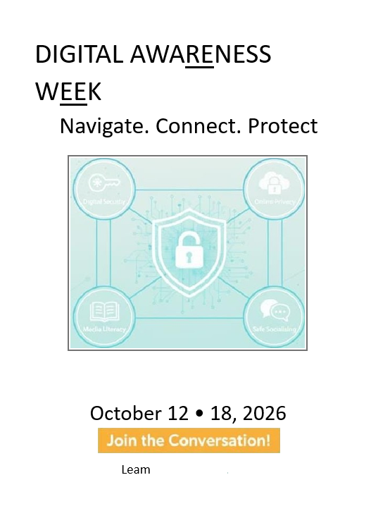

PRACTICAL-4

Aim- To draft and send a professional Internship email with attachment

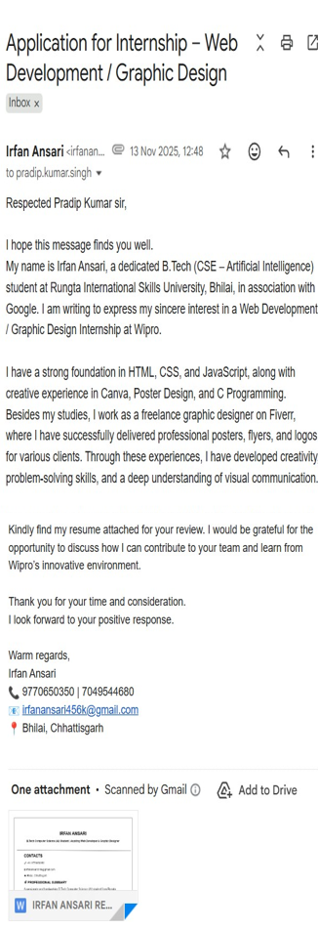

# PRATICAL - 5

Aim- Create a google form of Student attendance report

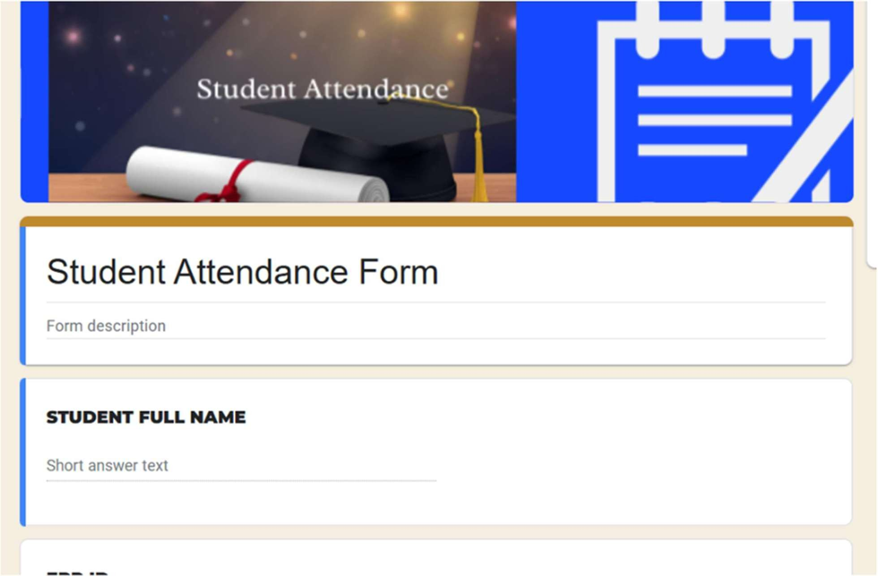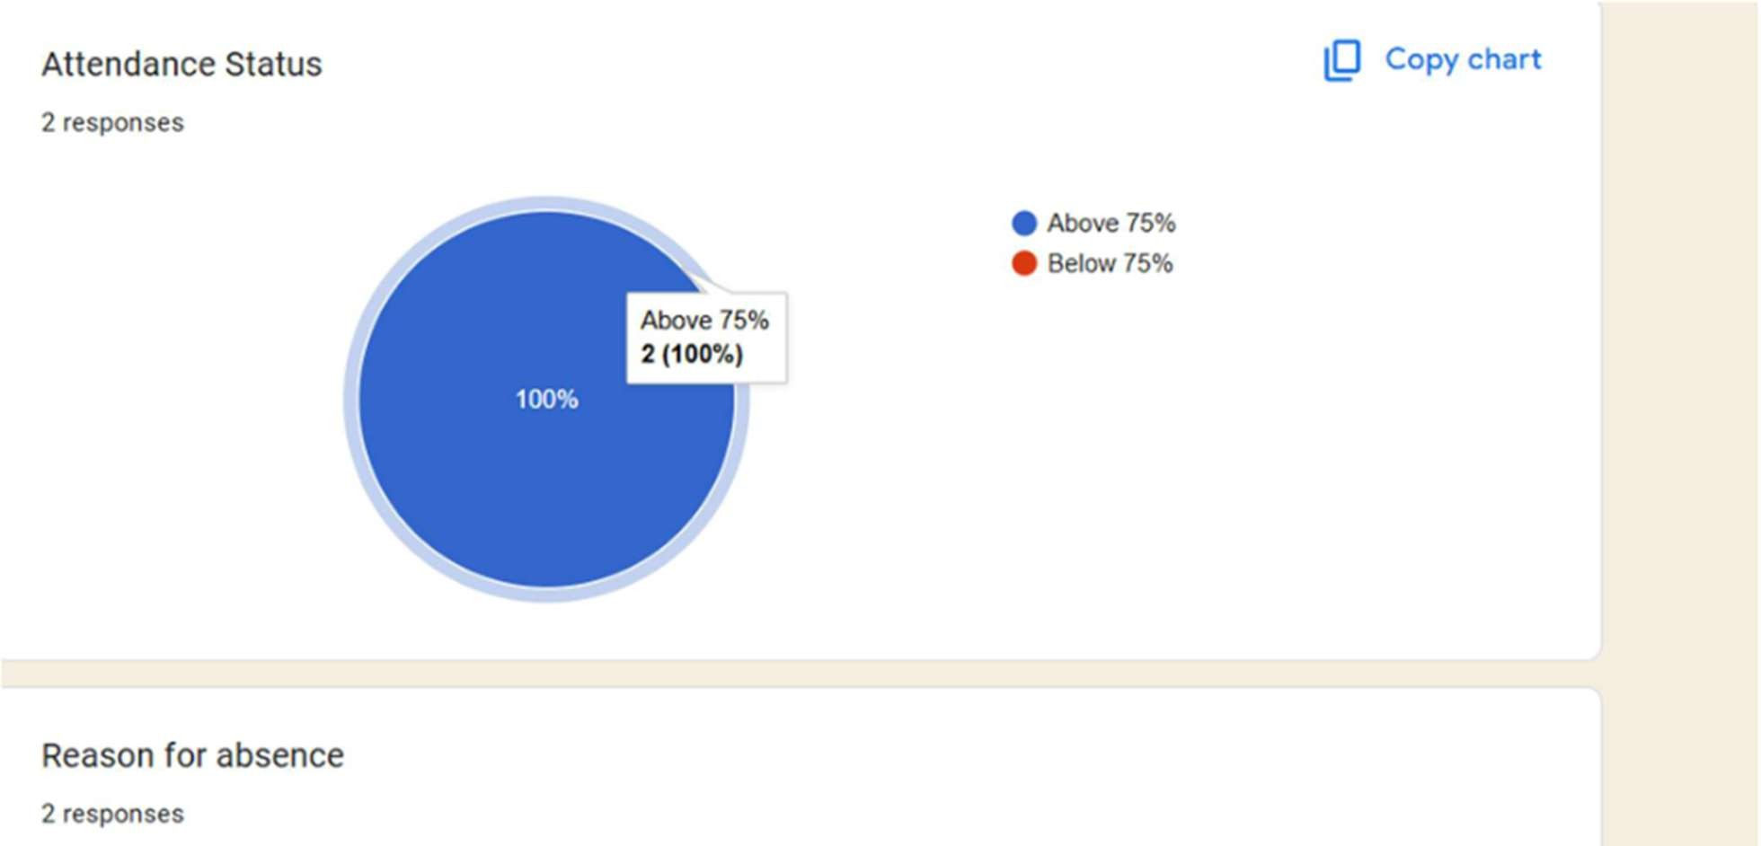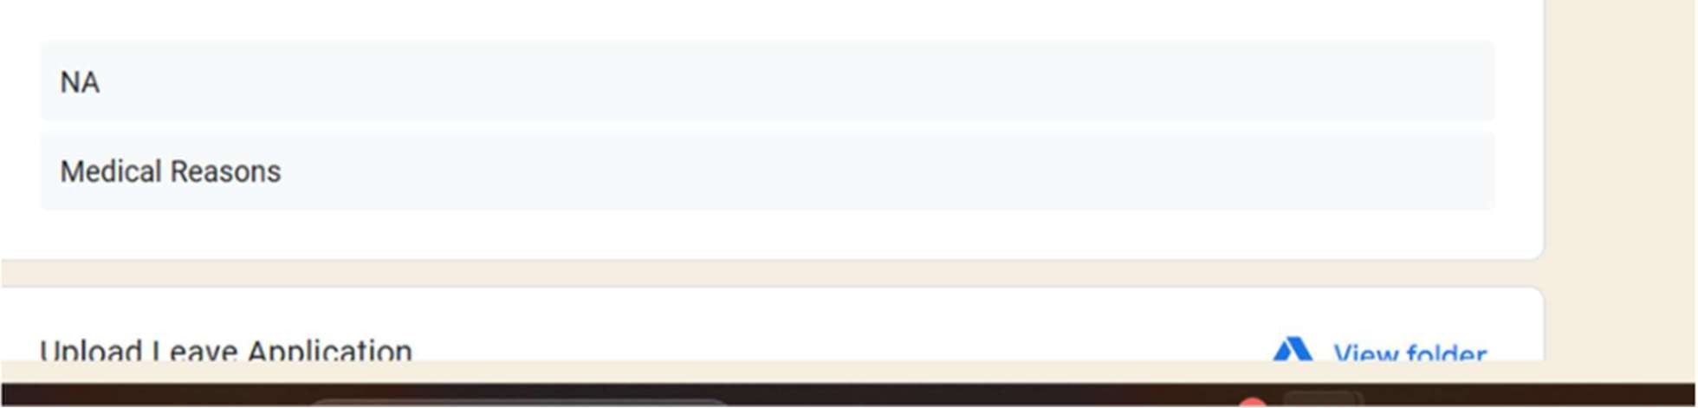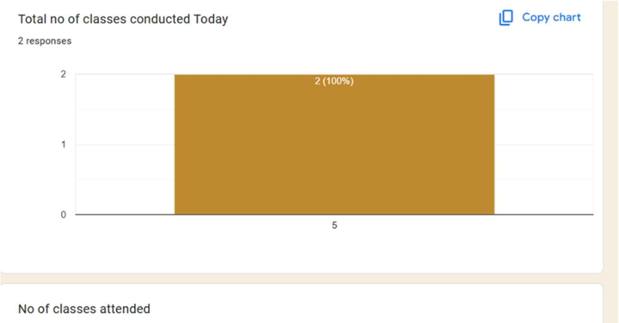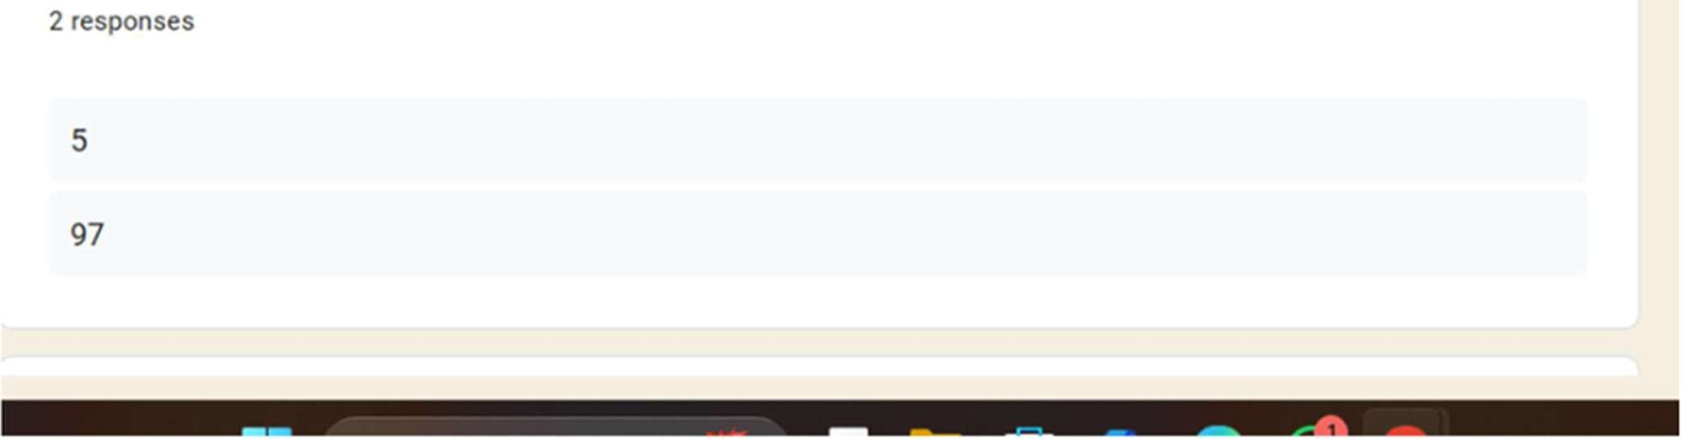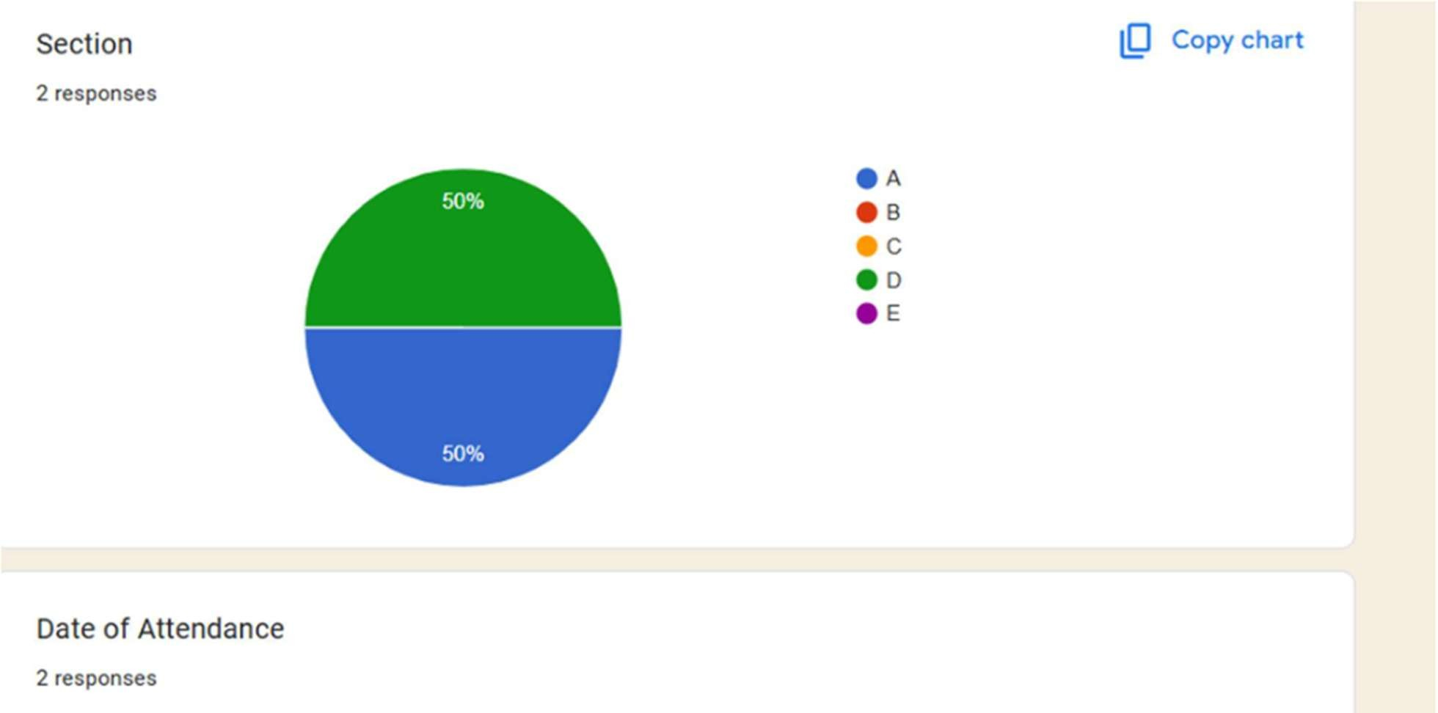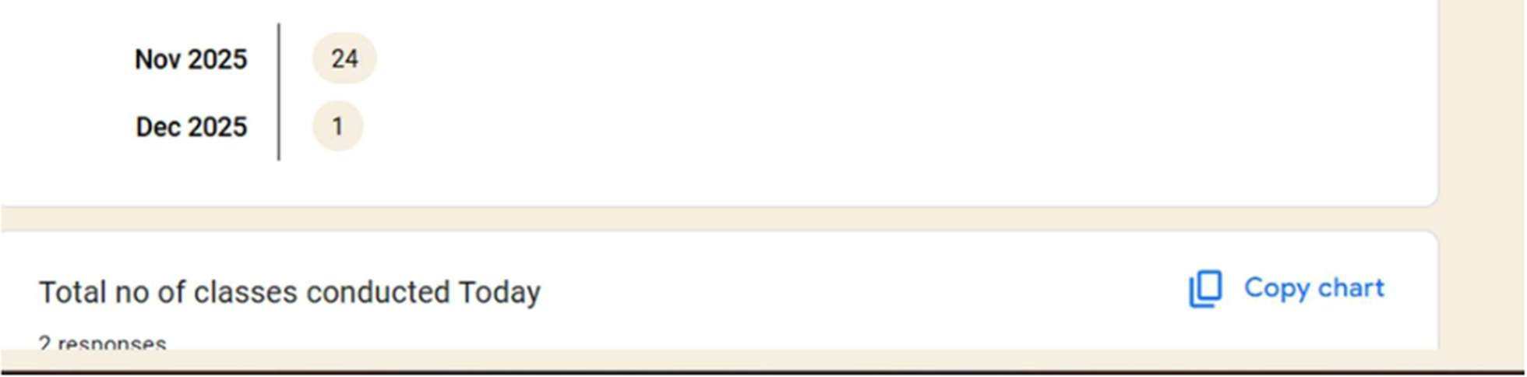

|  |  |
| --- | --- |
|  |  |

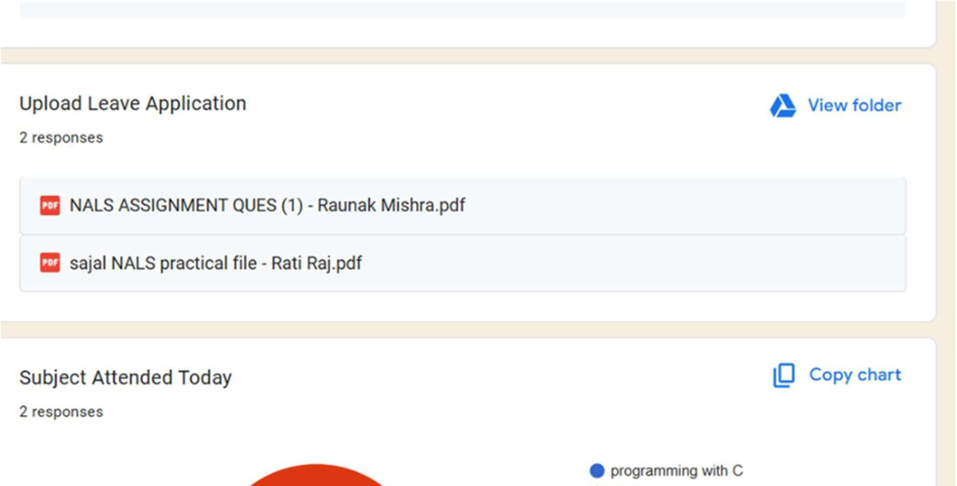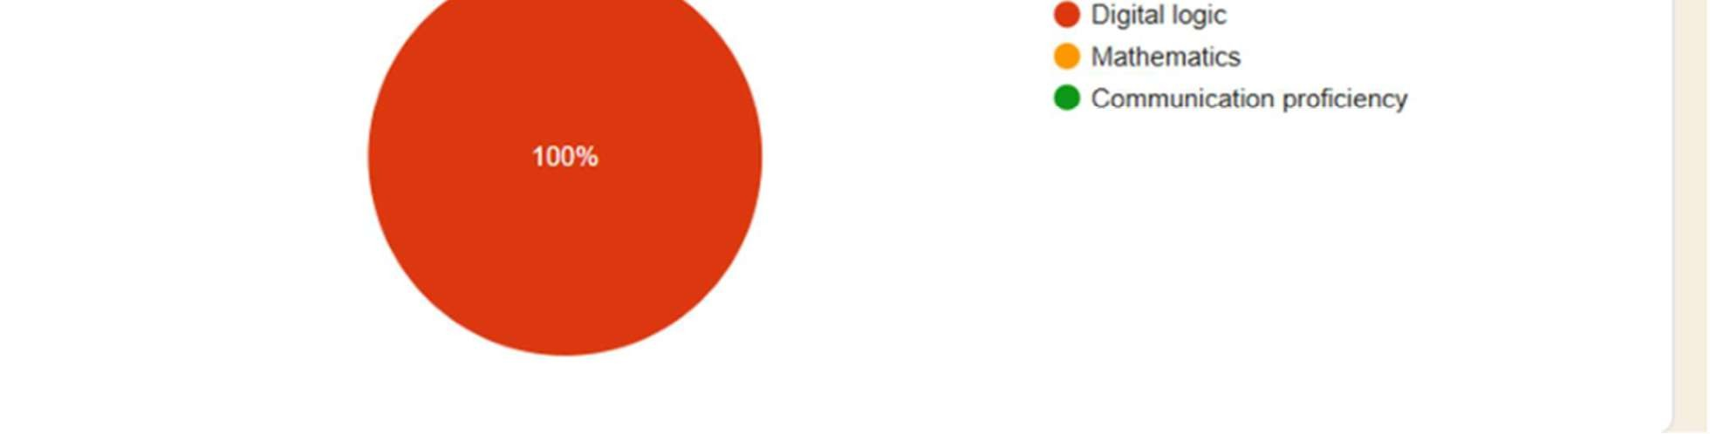

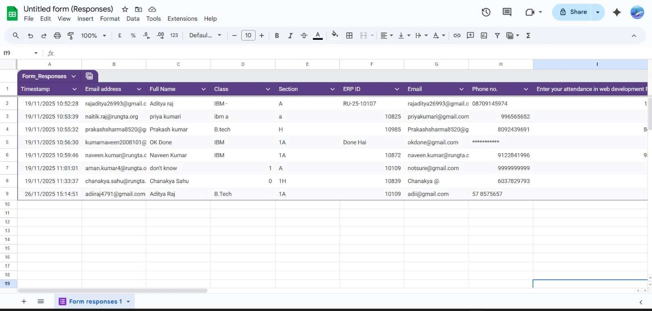

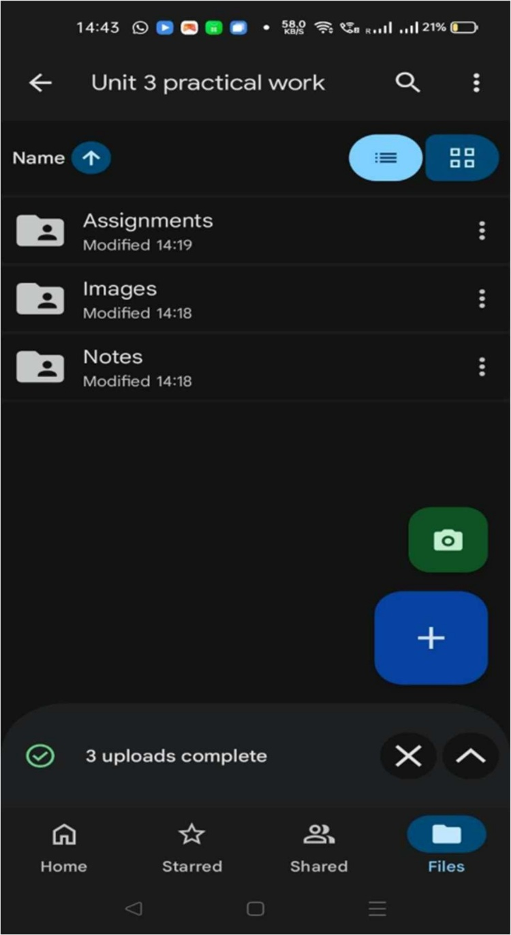

PRATICAL - 7

Aim- To upload and organize files and cloud storage

# PRACTICAL- 8

Aim-To identify phishing attempts through digital messages

“You are shortlisted for a Remote Software Developer role at Google.

Salary: ₹18 LPA.

Pay ₹2,499 as verification fee.

Limited seats. Pay now to confirm.”

ANSWER THE QUESTIONS :-

1. What type of cybercrime is happening here?

Ans- This is a type of Phishing or Job Scam.

* + It is called Phishing because the scammer is impersonating a reputable company (Google) to "lure" Aman into providing sensitive information (money/bank details).
  + Specifically, it is an Employment/Job Scam, aimed at defrauding money by offering the false promise of a job.

1. List 3 red flags that show it is a scam?

Ans-The following 3 points clearly indicate that this message is a scam:

Demand for a Verification Fee: No legitimate and large company (like Google) ever asks candidates for a "verification fee", security deposit, or processing fee to secure a job offer, especially in the initial stages. This is the biggest red flag

Overly Attractive, Vague Offer: An attractive salary of ₹18 LPA is offered, but this offer is made without any formal interview or selection process. Reputable companies, especially Google, do not extend final offers without a rigorous, multi-stage interview process

* 1. Urgency for Immediate Payment ('Limited Seats', 'Pay Now'): Scammers often use phrases like "limited seats" or "pay immediately" to create pressure and prevent the victim from thinking clearly. This is a common phishing tactic.

1. What should he do to verify if a job offer is real?

Ans-Aman should take these steps to verify the job offer:

* Check Google's Official Website: Aman should go directly to Google

Careers (Google's official career website) and see if the position (Remote Software Developer) is listed there. If it were a genuine position, it would always be found on Google's own website.

* Use Official Contact Information: Instead of replying to the LinkedIn message, he should contact Google's Recruiting department through the email or contact form provided on Google's official website and inquire about this offer.

Check the Source of the Message: On LinkedIn, he should check if the profile of the person sending the message is that of a genuine Google employee. He should examine that person's profile to see if actually work at Google and if their profile looks suspicious (e.g., recently created, very few connections, etc.).

# PRATICAL-9

Aim-To create a quiz with automatic grading and time limit

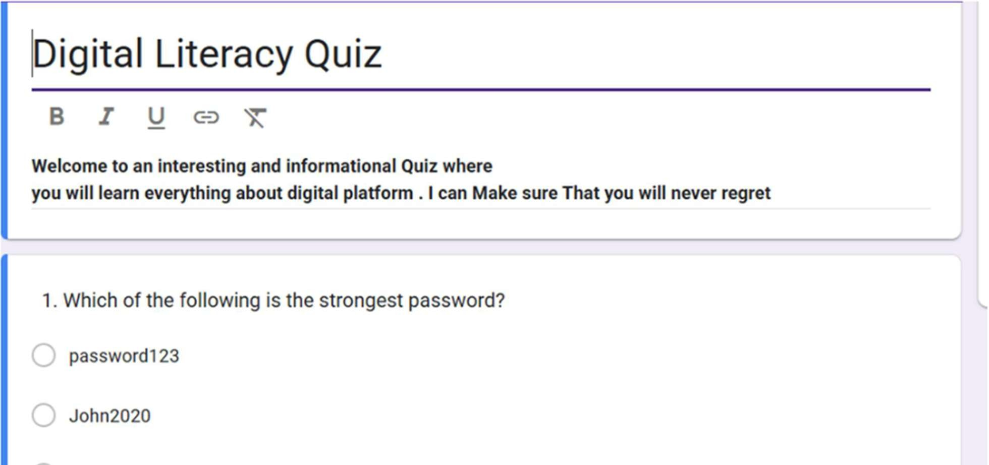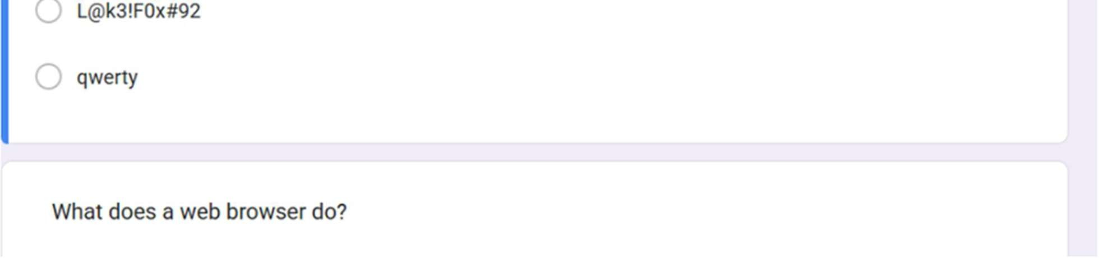

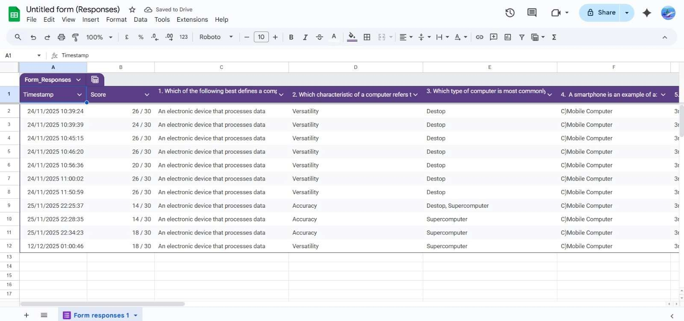

PRACTICAL- 10

Aim- To analyze AI Generated text for plagiarism and bias

Before:-

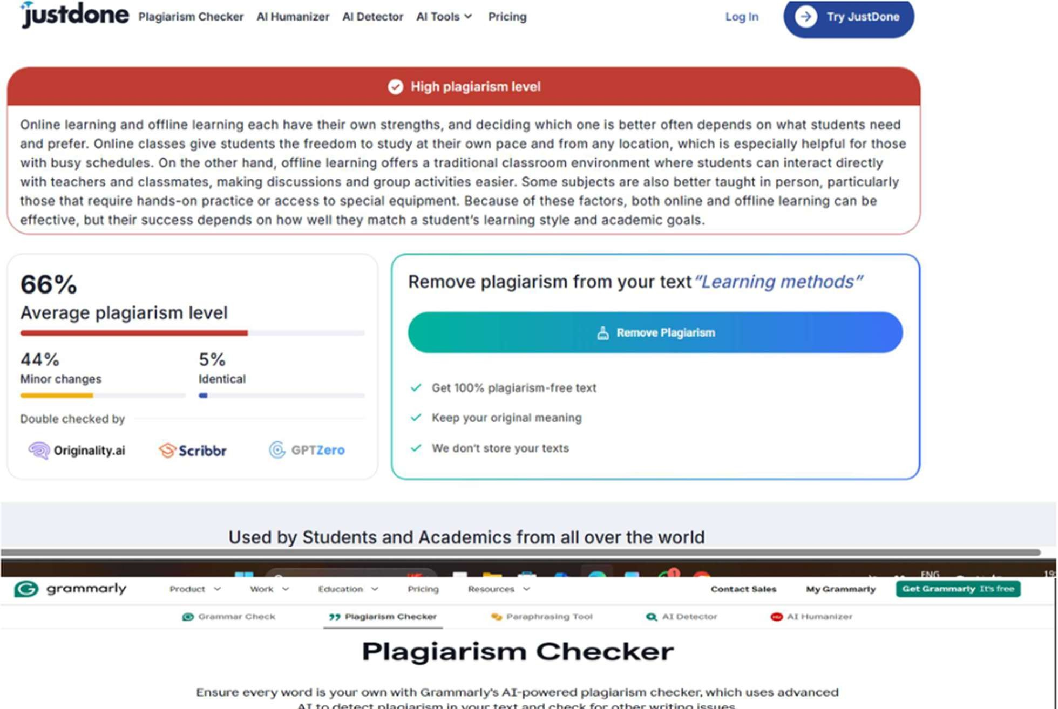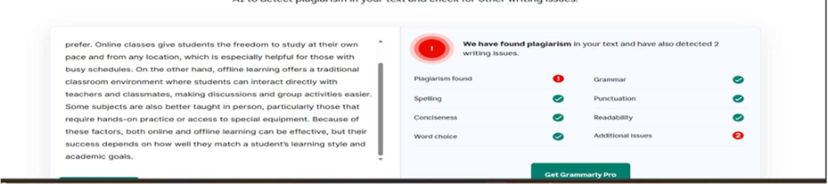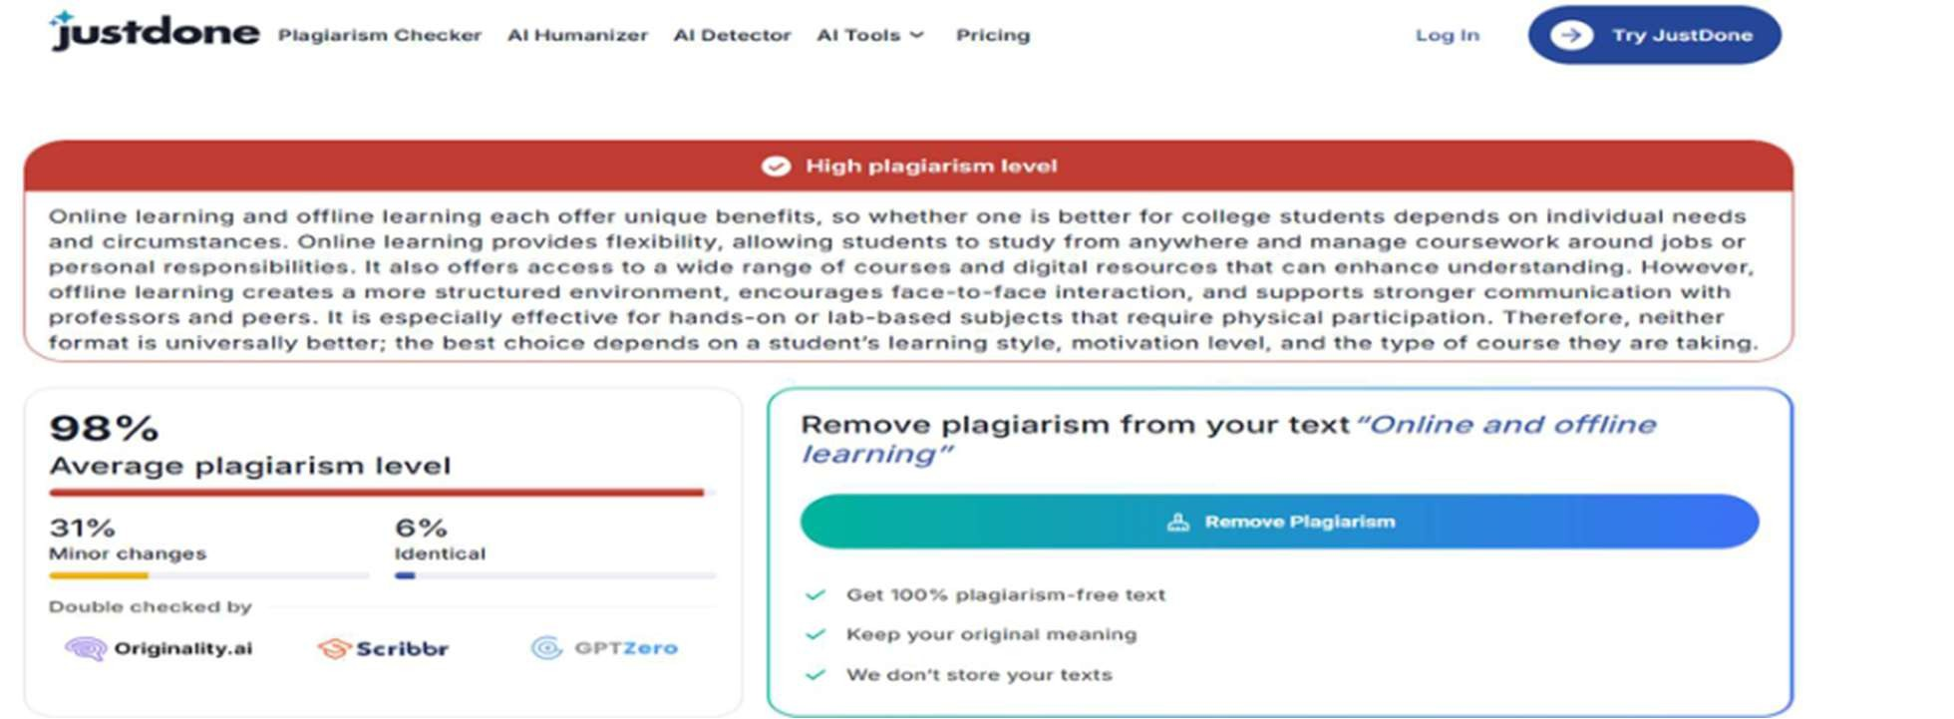

# PRACTICAL-11

Aim:- To compare AI-generated content with student-created content MY CONTENT:-

AI will definitely change the job market, but it won’t replace all jobs. Instead, it will automate repetitive tasks and push many roles to evolve. Some jobs may disappear, but new opportunities will also be created— especially in fields that require creativity, problem-solving, emotional intelligence, or human judgment. The key is to adapt, learn new skills, and work alongside AI rather than fear it. AI is a tool, not a total replacement for human capability.

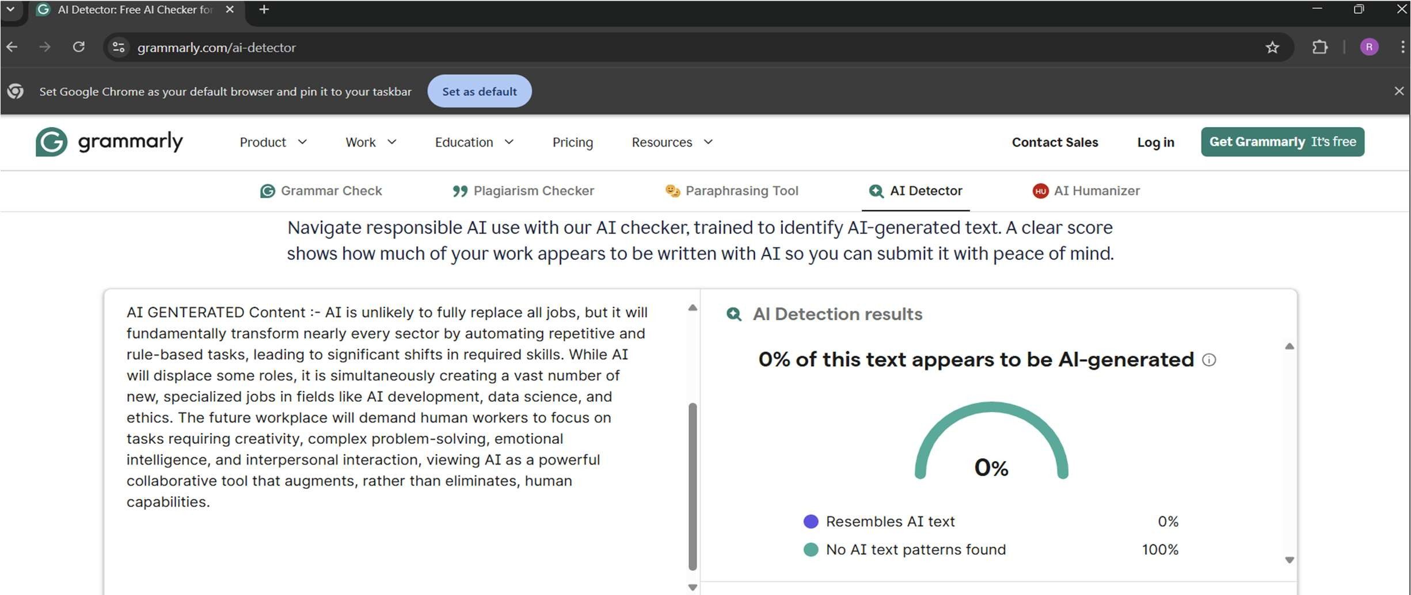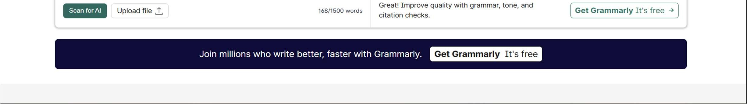

AI GENTERATED Content :- AI is unlikely to fully replace all jobs, but it will fundamentally transform nearly every sector by automating repetitive and rule-based tasks, leading to significant shifts in required skills. While AI will displace some roles, it is simultaneously creating a vast number of new, specialized jobs in fields like AI development, data science, and ethics. The future workplace will demand human workers to focus on tasks requiring creativity, complex problem-solving, emotional intelligence, and interpersonal interaction, viewing AI as a powerful collaborative tool that augments, rather than eliminates, human capabilities.

PRACTICAL-12

Aim:-To create revision notes using notebook LM

